भारत मौसम विज्ञान विभाग |  | India Meteorological Department
Wednesday 20th May 2026 (30th Vaisakha 1948 Saka)
Summary of observations recorded at 0830 hours IST: The Northern Limit of Monsoon continues to pass through 6°N/70°E, 6°N/75°E, 7°N/80°E, 9°N/85°E, 12°N/90°E, 14°N/93°E, 16°N/96°E and 17.5°N/98°E. Conditions are favourable for further advance of southwest monsoon into some more parts of southeast Arabian Sea, Comorin Area, southwest and southeast Bay of Bengal, remaining parts of Andaman Sea, and some more parts of eastcentral Bay of Bengal during next 3-4 days. The Southwest Monsoon is likely to set in over Kerala on 26th May with a model error of ± 4 days. The Western Disturbance as a cyclonic circulation over north Pakistan and adjoining Jammu persisted at 3.1 km above m. s. l. at 0830 hrs IST today morning. However, the trough aloft in middle tropospheric westerlies moved away eastwards at 0530 hrs IST of today morning. Another Western disturbance as a trough in westerlies with its axis at 5.8 km above m. s. l. ran roughly along Long. 52°E to the north of Lat. 30°N. An upper air cyclonic circulation over Punjab & neighbourhood at 0530 hrs IST of today morning. It seen over Punjab & adjoining Pakistan at 1.5 km above m. s. l. The upper air cyclonic circulation over East Uttar Pradesh & neighbourhood seen over central parts of north Uttar Pradesh at 0.9 km above m. s. l. A trough from the cyclonic circulation over East Uttar Pradesh & neighbourhood ran from central parts of north Uttar Pradesh to north Telangana across East Madhya Pradesh and Vidarbha 0.9 km above m. s. l. An upper air cyclonic circulation lay over west Bihar & neighbourhood at 0.9 km above m. s. l. An upper air cyclonic circulation lay over east Bangladesh & neighbourhood at 0.9 km above m. s. l. An upper air cyclonic circulation lay over Gangetic West Bengal & adjoining Bangladesh at 1.5 km above m. s. l. A trough ran from southeast Arabian Sea to the central Bay of Bengal across Lakshadweep, north Kerala, south interior Karnataka & Andhra Pradesh between 3.1 & 4.5 km above m. s. l. The upper air cyclonic circulation East Uttar Pradesh & neighbourhood and extended upto 1.5 km above m. s. l. Another trough ran from East Uttar Pradesh to north Telangana across East Madhya Pradesh and Vidarbha extended upto 1.5 km above m. s. l. The upper air cyclonic circulation over central Assam became less marked. The upper air cyclonic circulation over south Coastal Andhra Pradesh & neighbourhood became less marked. The trough from the cyclonic circulation over East Uttar Pradesh & neighbourhood to Manipur across north Gangetic West Bengal and Bangladesh became less marked. The trough from southeast Arabian Sea adjoining south Lakshadweep area to the cyclonic circulation over south Coastal Andhra Pradesh across Kerala, South Interior Karnataka and Rayalaseema also became less marked.
Maximum Temperature Departures (as on 19-05-2026): markedly above normal (> 5.1°C) at many places over East Madhya Pradesh; at most places over West Uttar Pradesh, Himachal Pradesh and West Madhya Pradesh; at few places over East Uttar Pradesh. appreciably above normal (3.1°C to 5.0°C) at few places over Coastal Andhra Pradesh & Yanam; at isolated places over Tamil Nadu, Puducherry & Karaikal. above normal (1.6°C to 3.0°C) at few places over Rayalaseema. near normal (-1.5°C to 1.5°C) at most places over Konkan & Goa; at isolated places over Kerala & Mahe. The highest maximum temperature of 48.2°C was reported at Banda (Uttar Pradesh).
Heat wave to severe heat wave conditions (from 0830 hours IST of yesterday to 0530 hours IST of today): Heat wave to severe heat wave conditions prevailed in isolated pockets over East Uttar Pradesh; heat wave conditions in few pockets of Punjab, Haryana-Chandigarh-Delhi, West Uttar Pradesh; in isolated pockets over Jammu Division, Madhya Pradesh and Vidarbha.
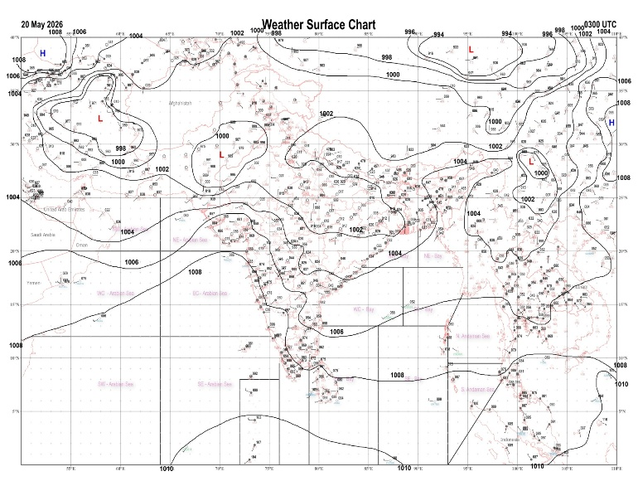 | 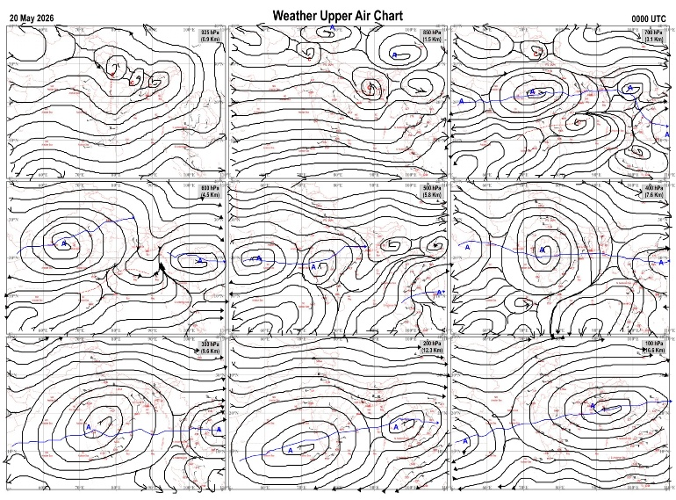
Fig.1. Analysed surface chart based on 03z observation | Fig.2. Analysed upper air chart based on 00z observation
Prakash Chand
Scientific Officer-‘I’
CR & S Office, Pune  Issued at 1245 hrs. IST |  | Weather Forecasting Division  CR&S, Pune

Indian regions | Realised rainfall (chief amount in cm during past 24 hrs):
East | isolated places: Arunachal Pradesh◆, Assam & Meghalaya, Nagaland-Manipur-Mizoram-Tripura, West Bengal & Sikkim, Odisha, Jharkhand and Bihar  Rasagovindapur 4.3, Similiguda 3.4, Bhaghmara 1.9, Jhallong 1.7, Koraput 1.5, Mangalkote & Gurabandha 1.4 each, Gandecherra 1.3, Baghmara AWS, Amarpur & Suryagadha 0.9 each, Baharagora 0.8, Darjeeling & Burdwan PTO 0.6 each, Tribeni / Balmikinagar 0.4, Majitar & Contai 0.3 each, Bomdila AWS 0.1.
North | isolated places: Uttarakhand, Himachal Pradesh and Jammu-Kashmir and Ladakh◆  dry weather: Uttar Pradesh, Haryana, Punjab and Rajasthan  Dharchula 2.5, Bhuntar AP 1.9, Joshimath 1.7, Munsiyari 0.6, Sangla & Kukernag 0.2 each, Bandipora AWS & Bhaderwah ARG 0.1 each.
Central | isolated places: Chhattisgarh  dry weather: Madhya Pradesh and Vidarbha  Durg 0.5.
Peninsula | a few places: Kerala  isolated places: Konkan & Goa◆, Marathwada, coastal Andhra Pradesh, Telangana, Rayalaseema, Tamil Nadu, coastal Karnataka and interior Karnataka  dry weather: Gujarat State and Madhya Maharashtra  Ulundurpet 6.0, Santhipuram 5.6, Kalakada 5.5, Basl vengur 4.9, Gowribidanur 3.7, Pilicode AWS 3.5, Yedrami 3.4, Tirupathur PTO 3.2, Maski 2.3, Pirappancode AWS 1.8, Kunavaram & Vellanikkara 1.6 each, Jainoor 1.4, Ballari AWS 1.3, Araku valley, Chegunta & Belthangadi 1.2 each, Mudubidre 1.0, Vijayapura PTO 0.8, Umarga 0.3, Mangaluru AP 0.2, Canacona 0.1.
Islands | most places: Lakshadweep  a few places: Andaman & Nicobar  Iaf carnicobar 3.6, Nancowry & Amini 2.9 each, Hut bay 1.1, Agathi 0.8, Minicoy 0.5.
Table-2 Forecast / warnings (distribution of rain / thundershowers) for 7 days (valid from time of origin upto 0830 hrs IST of next day)
Sr N. |  | Sub-division Name | Day 1 | Day 2 | Day 3 | Day 4 | Day 5 | Day 6 | Day 7 | Sr. No. | Sub-division Name | Day 1 | Day 2 | Day 3 | Day 4 | Day 5 | Day 6 | Day 7
 |  |  | 20 May | 21 May | 22 May | 23 May | 24 May | 25 May | 26 May |  |  | 20 May | 21 May | 22 May | 23 May | 24 May | 25 May | 26 May
 | 1 | Andaman Nicobar Islands | W +  | W +  | W +  | W  | W  | W +  |  | 19 | west Madhya Pradesh | D + | D + | D + | D + | D + | D + | D +
 | 2 | Arunachal Pradesh | S | S | F +  | W++ | W++ | W + |  | 20 | east Madhya Pradesh | D + | D + | D + | D + | D + | D+ | D+
 | 3 | Assam-Meghalaya | S  | S +  | F+  | W++ | W++ | W ++ |  | 21 | Gujarat region | D | D | D | D | D | D | D
 | 4 | Nagaland-Manipur-Mizoram-Tripura | I  | S  | S +  | F +  | F +  | F + |  | 22 | Saurashtra and Kutch | D | D | D | D | D | D | D
 | 5 | Sub Him West Bengal/Sikkim | S  | F +  | W ++  | W ++  | W ++  | W + |  | 23 | Konkan and Goa | I  | I  | I | I | I | I | I
 | 6 | Gangetic West Bengal | I  + | I  + | I  + | I  + | I + | I |  | 24 | Madhya Maharashtra | I  | I  | I | I | I | I | I
 | 7 | Odisha | I  + | I  + | I  + | I  + | I  + | I  |  | 25 | Marathwada | I  | I | D | D | D | D | D
 | 8 | Jharkhand | I  | I  | I  | I  | I  | I |  | 26 | Vidarbha | D + | D + | D + | D + | D + | D + | D +
 | 9 | Bihar | I  + | I  + | S  + | I  + | I  | I  |  | 27 | Chhattisgarh | D + | D + | D + | D + | D + | D | D
 | 10 | east Uttar Pradesh | D + | D + | D + | D + | D + | I + |  | 28 | Coastal Andhra Pradesh and Yanam | I  + | I  + | I  + | I  + | I  + | D | D
 | 11 | west Uttar Pradesh | D + | D + | D + | D + | D + | D + |  | 29 | Telangana | I  + | D  + | D + | D + | D + | D | D
 | 12 | Uttarakhand | I + | I + | I  | I  | I | I |  | 30 | Rayalaseema | I  | S  | S | S | I | I | I
 | 13 | Haryana,Chandigarh and Delhi | D + | D + | D + | D + | D + | D + |  | 31 | Tamil Nadu, Puducherry and Karaikal | I +  + | I +  + | I +  + | I  + | S  | S | I
 | 14 | Punjab | D + | D + | D + | D + | D + | D+ |  | 32 | Coastal Karnataka | S  | S  | S  | S  | S  | S | S
 | 15 | Himachal Pradesh | I + | I+ | S  | I  | I | I |  | 33 | North interior Karnataka | I  | I  | S  | S  | I  | I | I
 | 16 | Jammu-Kashmir and Ladakh | S+ | F  | S  | S | S | I |  | 34 | South interior Karnataka | S + | S +  | S  | S  | S  | I | I
 | 17 | west Rajasthan | D + | D + | D + | D + | D + | D+ | D+ | 35 | Kerala and Mahe | W + | W +  | F  | F | F | F | F
 | 18 | east Rajasthan | D + | D + | D + | D + | D + | D+ | D+ | 36 | Lakshadweep | W+ | W  | F  | F | F | F | F
Legends: D = Dry I =isolated S = Scattered F = Fairly widespread W = Widespread #= heavy to very heavy rain at a few places with extremely heavy rain at isolated places+++= heavy rain at a few places with very heavy rain at isoIated places++= heavy to very heavy rainfall @=isolated exceptionally heavy rainfall+ = heavy rain ●/*= rain or snow ♦ = very light rain ≡=fog = thunderstorm with lightning =Squall / Gusty / gale / strong wind -=cold wave/cold day + = heat wave/warm night/hot and humid weather =Duststorm =ground frost = Hail.

Fig. 4: Districtwise warnings for five days for Maharashtra State
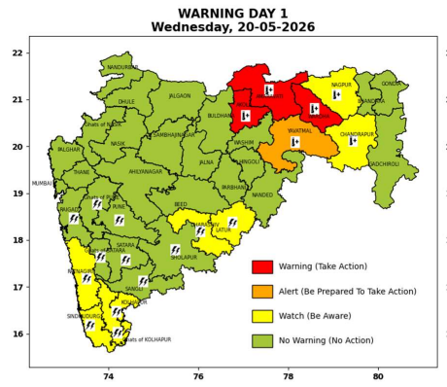 | 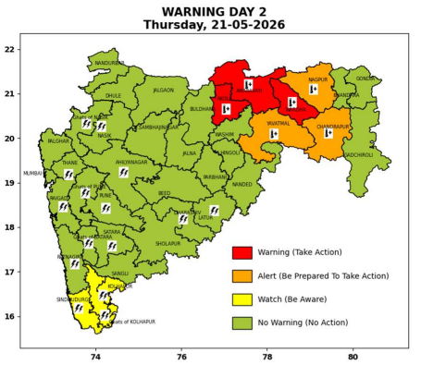 | 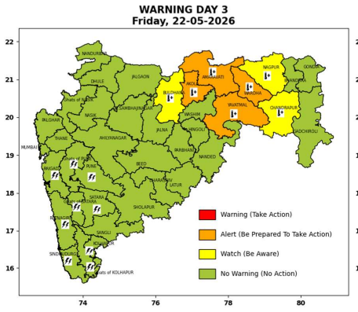 | 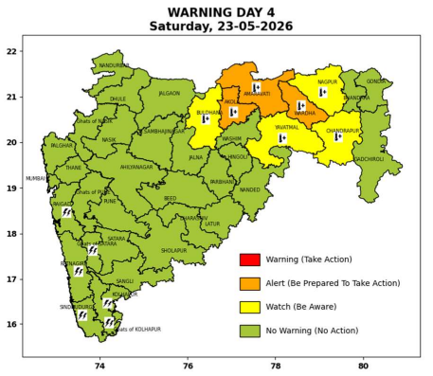 | 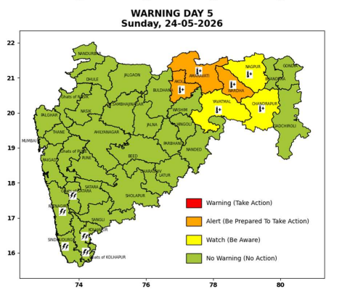

Pune, Lohegaon and Pashan observations at 0830 hrs. IST of Today
 | Temperature (°C) |  |  |  |  | Humidity (%) |  |  |  | Rainfall (mm)
 | Max.  past  24 hrs | Dep.  from  normal | Min.  past  24 hrs. | Dep.  from  normal | Dry  Bulb | At 0830 hrs. IST | Dep.  From  normal | At 1730  hrs. IST of y’day | Dep.  from  normal | Past  24 hrs. | Since  1st March | Dep.  from  normal
PNE | 36.8 | -0.1 | 23.9 | 0.5 | 26.5 | 65 | 5 | 43 | 5 | 0.0 | 92.8 | 61.9
PSN | 37.1 | - | 22.9 | - | 26.4 | 70 | - | 47 | - | 0.0 | - | -
LHG | 38.2 | 1.2 | 24.2 | 3.2 | 27.1 | 65 | 5 | 42 | 6 | 0.0 | 91.4 | 53.5

 |  |  |  |  |  |  | Local (Pune and neighbourhood) forecast
Max./Min. Temperature (°C) |  |  |  |  |  |  |  |  | Weather
Date | Pune | Pashan | Lohegaon | Chinchwad | Lavale | Magarpatta | NDA | Koregoan park
20/05/26 | 37 / 23.9* | 36 / 22.9* | 38 / 24.2* | 36 / 24.4* | 36 / 21.1* | 38 / - | 35 / 22.5* | 36 / - | Mainly clear sky becoming partly cloudy sky towards afternoon or evening.
21/05/26 | 37 / 24 | 36 / 23 | 38 / 24 | 36 / 24 | 36 / 21 | 37 / 24 | 35 / 23 | 36 / 24 | Mainly clear sky becoming partly cloudy sky towards afternoon or evening.
22/05/26 | 36 / 24 | 36 / 23 | 38 / 24 | 35 / 24 | 35 / 21 | 37 / 24 | 35 / 22 | 36 / 24 | Mainly clear sky becoming partly cloudy sky towards afternoon or evening. Thunderstorm with lightening, very light rain likely.
23/05/26 | 36 / 23 | 36 / 22 | 37 / 23 | 35 / 23 | 35 / 20 | 36 / 23 | 35 / 22 | 35 / 23 | Mainly clear sky becoming partly cloudy sky towards afternoon or evening. Thunderstorm with lightening, very light rain likely.
24/05/26 | 36 / 23 | 36 / 22 | 37 / 23 | 35 / 23 | 35 / 20 | 36 / 23 | 35 / 22 | 35 / 23 | Mainly clear sky becoming partly cloudy sky towards afternoon or evening. Thunderstorm with lightening, very light rain likely.
25/05/26 | 36 / 23 | 36 / 22 | 37 / 23 | 35 / 23 | 35 / 20 | 36 / 23 | 34 / 21 | 35 / 23 | Mainly clear sky becoming partly cloudy sky towards afternoon or evening. Thunderstorm with lightening, very light rain likely.
26/05/26 | 36 / 23 | 36 / 22 | 37 / 23 | 35 / 23 | 35 / 20 | 36 / 23 | 34 / 21 | 35 / 23 | Mainly clear sky becoming partly cloudy sky towards afternoon or evening. Thunderstorm with lightening, very light rain likely.
Rainfall Distribution |  |  |  |  | Rainfall Categories | Rainfall (mm) | Cloud condition |  | Rainfall Intensity | Range
Widespread (W) | 76-100% |  |  |  | Very Light rain | Trace to 2.4 mm | Mainly clear sky | 1-2 oktas | Light Spell | 1 cm/hr
 |  |  |  |  | Light rain | 2.5 to 15.5 mm | Partly cloudy sky | 3-4 oktas | Moderate Spell | 1-2 cm/hr
Fairly Widespread (FW) | 51 – 75% |  |  |  | Moderate rain | 15.6 to 64.4 mm | Generally cloudy sky | 5-7 oktas | Intense Spell | 2-3 cm/hr
Scattered (S) | 26 – 50% |  |  |  | Heavy rain | 64.5 to 115.5 mm | Overcast | 8 oktas | Very Intense Spell | 3-5 cm/hr
Isolated (I) | 1 – 25% |  |  |  | Very heavy rain | 115.6 to 204.4 mm |  |  | Extremely Intense Spell | 5-10 cm/hr
Dry (D) | No Rain |  |  |  | Extremely heavy rain | ≥ 204.5 mm |  |  | Cloudburst | > 10 cm/hr
Probability Terms in %: |  |  |  |  | Heavy snow | 6.5 to 11.5 cms water equivalent of rain
unlikely | < 25 |  |  |  | Very heavy snow | 11.6 to 20.4 cms water equivalent of rain
likely | between 25 50
very likely | between 51 75
most likely | >75
* = realized temperatu
Mumbai (Colaba) |  |  |  | Nagpur (AP)
Date 2026 | T max °C | T min °C | Weather | T max °C | T min °C | Weather
20/05/26 | 34 | 27 | Clear sky. | 45 | 28 | Heat Wave.
21/05/26 | 34 | 27 | Clear sky. | 46 | 29 | Heat Wave.
22/05/26 | 35 | 27 | Clear sky. | 45 | 26 | Heat Wave.
23/05/26 | 34 | 27 | Clear sky. | 45 | 26 | Heat Wave.
24/05/26 | 34 | 27 | Clear sky. | 45 | 27 | Heat Wave.
25/05/26 | 34 | 27 | Clear sky. | 45 | 26 | Mainly clear sky.
26/05/26 | 34 | 27 | Clear sky. | 44 | 26 | Mainly clear sky.

